Step 1:ssh username@raijin.nci.org.au

Step 2:cat transfer1.c

#include <stdio.h>

#include <mpi.h>

#include <stdlib.h>

#include <unistd.h>

int main(int argc, char** argv)

{

int localID;

int numOfPros;

int loop = 20;

int skip = 5;

int i;

MPI_Status reqstat;

double t_start, t_end, t;

size_t Gsize = (size_t) 400 * 1024 * 1024;

char* s_buf = (char*)malloc(Gsize);

char* r_buf = (char*)malloc(Gsize);

MPI_Init(&argc, &argv);

MPI_Comm_size(MPI_COMM_WORLD, &numOfPros);

MPI_Comm_rank(MPI_COMM_WORLD, &localID);

if (localID == 0)

{

for (i==0; i<loop+skip; i++) {

if(i==skip) {

t_start = MPI_Wtime();

}

MPI_Send(s_buf, Gsize, MPI_CHAR, 1, 1, MPI_COMM_WORLD);

MPI_Recv(r_buf, Gsize, MPI_CHAR, 1, 1, MPI_COMM_WORLD, &reqstat);

}

t_end = MPI_Wtime();

t = t_end - t_start;

} else if (localID == 1)

{

for(i=0; i<loop+skip; i++) {

MPI_Recv(r_buf, Gsize, MPI_CHAR, 0, 1, MPI_COMM_WORLD, &reqstat);

MPI_Send(s_buf, Gsize, MPI_CHAR, 0, 1, MPI_COMM_WORLD);

}

}

if(localID == 0) {

printf("time per 1GB: %f secs\n", 1.0 * t / loop);

}

if(s_buf!=NULL)

free(s_buf);

if(r_buf!=NULL)

free(r_buf);

MPI_Finalize();

return 0;

}

Step 3: module load openmpi/1.8.2

Step 4: mpicc transfer1.c –o transfer1

Step 5: mpirun –np 2 –host r11,r12 –report-bindings --mca btl self,sm,tcp ./transfer1

Step 6: mpirun –np 2 -host r11,r12 –report-bindings --mca btl self,sm,openib ./transfer1

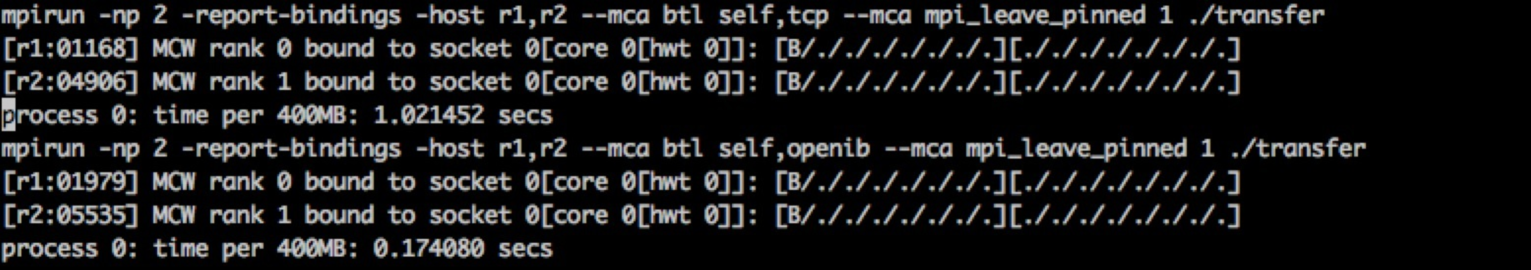

Step 7: vim transfer.c

#include <stdio.h>

#include <mpi.h>

#include <stdlib.h>

#include <unistd.h>

int main(int argc, char** argv)

{

int localID;

int numOfPros;

int loop = 20;

int skip = 5;

int i;

MPI_Status reqstat;

double t_start, t_end, t;

size_t Gsize = (size_t) 400 * 1024 * 1024;

char* s_buf = (char*)malloc(Gsize);

char* r_buf = (char*)malloc(Gsize);

MPI_Init(&argc, &argv);

MPI_Comm_size(MPI_COMM_WORLD, &numOfPros);

MPI_Comm_rank(MPI_COMM_WORLD, &localID);

if (localID %2 == 0)

{

for (i==0; i<loop+skip; i++) {

if(i==skip) {

t_start = MPI_Wtime();

}

MPI_Send(s_buf, Gsize, MPI_CHAR, localID+1, 1, MPI_COMM_WORLD);

MPI_Recv(r_buf, Gsize, MPI_CHAR, localID+1, 1, MPI_COMM_WORLD, &reqstat);

}

t_end = MPI_Wtime();

t = t_end - t_start;

} else if (localID %2 == 1)

{

for(i=0; i<loop+skip; i++) {

MPI_Recv(r_buf, Gsize, MPI_CHAR, localID-1, 1, MPI_COMM_WORLD, &reqstat);

MPI_Send(s_buf, Gsize, MPI_CHAR, localID-1, 1, MPI_COMM_WORLD);

}

}

if(localID %2 == 0) {

printf("process %d: time per 1GB: %f secs\n",localID, 1.0 * t / loop);

}

if(s_buf!=NULL)

free(s_buf);

if(r_buf!=NULL)

free(r_buf);

MPI_Finalize();

return 0;

}

Step 8: mpicc transfer.c -o transfer

mpirun -np 8 -report-bindings -host r1,r2 --map-by node -bind-to socket --mca btl self,tcp --mca mpi_leave_pinned 1 ./transfer

mpirun -np 8 -report-bindings -host r1,r2 --map-by node -bind-to socket --mca btl self,openib --mca mpi_leave_pinned 1 ./transfer

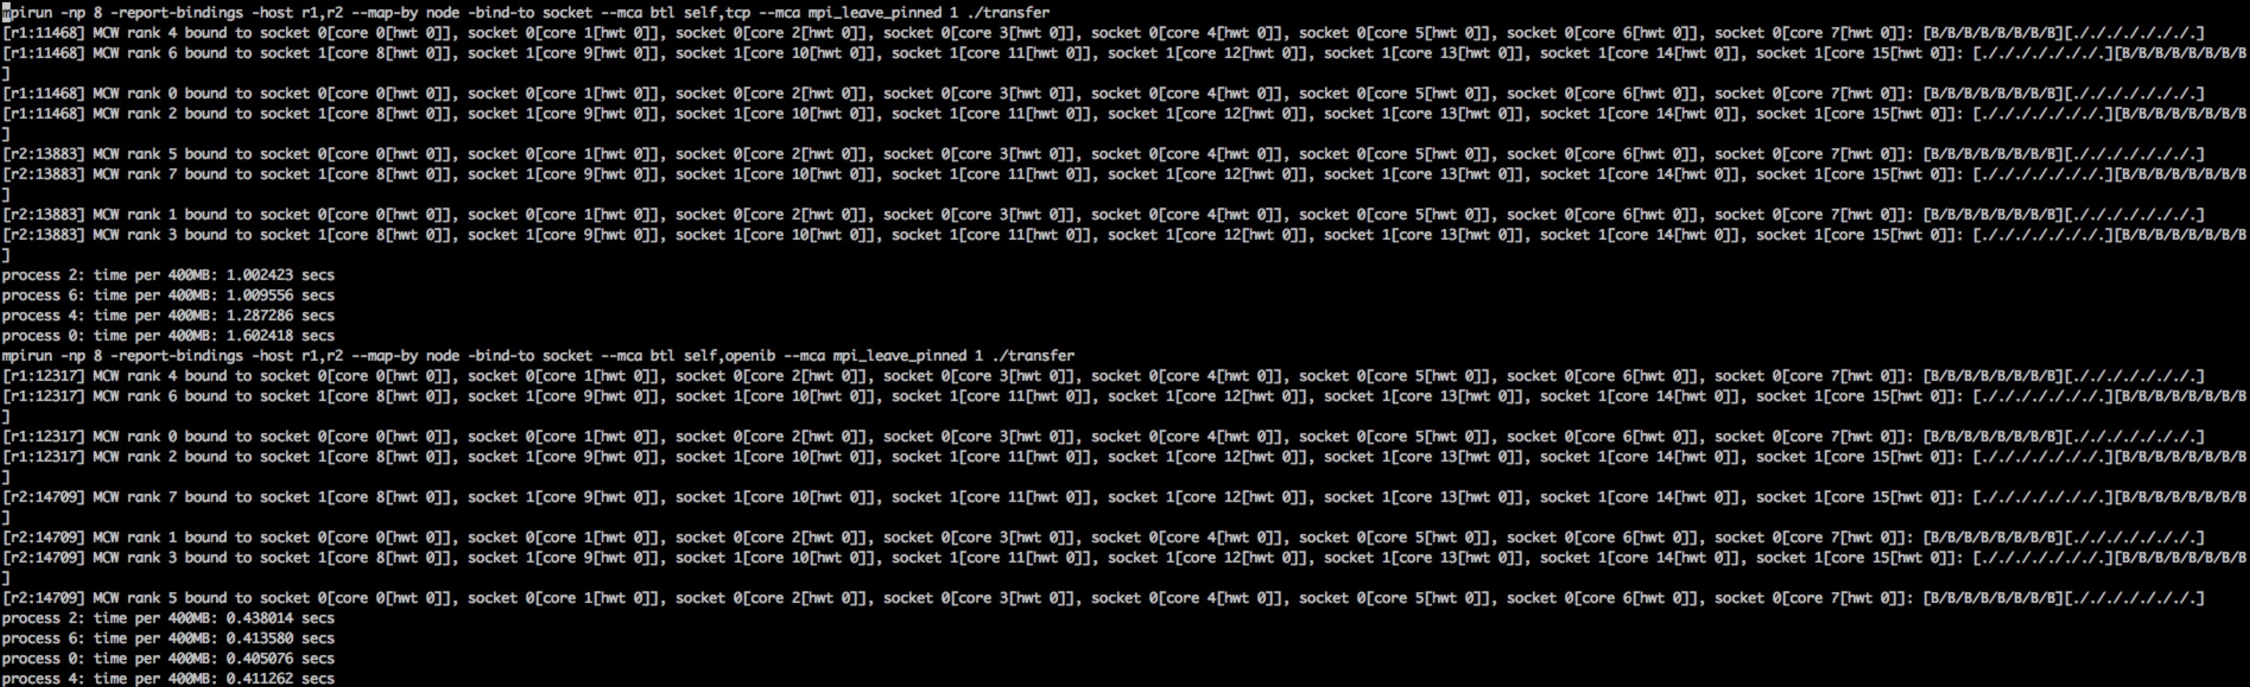

Result:

|  |  |  |  |  |  |  |  |  |  |  |
| --- | --- | --- | --- | --- | --- | --- | --- | --- | --- | --- |
| host-host | host-host | host-host | host-host | host-host | host-host | host-host | host-host | host-host | host-host | host-host |
| Protocol | RDMA | **TCP** | **TCP** | TCP | TCP | TCP | RDMA | RDMA | RDMA | RDMA |
| Num of transfer | **1** | **1** | **4** | | | | **4** | | | |
|
| **Process0** | **Process2** | **Process4** | **Process6** | **Process0** | **Process2** | **Process4** | **Process6** |
| No.1 | 0.174 | 1.021 | 1.602 | 1.002 | 1.287 | 1.010 | 0.405 | 0.438 | 0.411 | 0.414 |
| No.2 | 0.172 | 1.385 | 1.438 | 0.772 | 1.394 | 1.005 | 0.427 | 0.427 | 0.422 | 0.432 |
| No.3 | 0.174 | 0.942 | 1.548 | 0.936 | 1.367 | 0.873 | 0.338 | 0.351 | 0.339 | 0.336 |
| No.4 | 0.171 | 1.260 | 1.438 | 1.017 | 1.511 | 0.991 | 0.456 | 0.472 | 0.444 | 0.470 |
| No.5 | 0.172 | 0.913 | 1.357 | 1.024 | 1.461 | 1.156 | 0.400 | 0.410 | 0.394 | 0.408 |
| No.6 | 0.175 | 1.336 | 1.599 | 0.933 | 1.293 | 1.034 | 0.412 | 0.427 | 0.428 | 0.426 |
| No.7 | 0.174 | 0.951 | 1.502 | 1.037 | 1.487 | 0.856 | 0.452 | 0.448 | 0.440 | 0.462 |
| No.8 | 0.173 | 0.829 | 1.403 | 1.028 | 1.770 | 1.132 | 0.415 | 0.424 | 0.434 | 0.449 |
| No.9 | 0.175 | 1.286 | 1.364 | 0.774 | 1.591 | 0.934 | 0.418 | 0.417 | 0.427 | 0.427 |
| No.10 | 0.171 | 1.049 | 1.414 | 1.229 | 1.601 | 1.170 | 0.416 | 0.408 | 0.404 | 0.405 |
| Average | 0.173 | 1.097 | 1.467 | 0.975 | 1.476 | 1.016 | 0.414 | 0.422 | 0.414 | 0.423 |

Step 9: create two instances of VMs on NCI’s openstack cloud

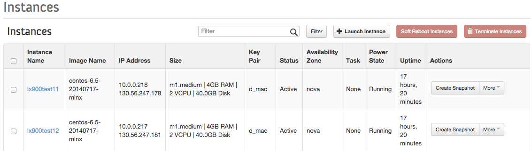

Each VM is set with 4GB RAM, 2VCPU and 40GB Disk. We selected to use CentOS 6.5 images.

The real host is set with Intel Sandy Bridge E5-2670 processor(8 -core), 2CPU, 32GB RAM. The network communication link is InfiniBand FDR(56Gb/s).

Step 10:

yum –y install openmpi-devel

Step 11: useradd test

passwd test

Step 12: su test

vim .bashrc (added following)

PATH=/usr/lib64/openmpi/bin:$PATH

LD_LIBRARY_PATH=/usr/lib64/openmpi/lib:$LD_LIBRARY_PATH

export PATH LD_LIBRARY_PATH

Step 13: ssh-keygen

scp .ssh/id_rsa.pub test@test12:~/.ssh/authorized_keys

chmod 600 ~/.ssh/authorized_keys

Step 14: mpicc transfer1.c –o transfer1

mpirun –np 2 –report-bindings –host test11,test12 --mca btl tcp,sm,self ./transfer1

[test11:10079] MCW rank 0 bound to socket 0[core 0[hwt 0]]: [B][.]

[test12:09981] MCW rank 1 bound to socket 0[core 0[hwt 0]]: [B][.]

time per 1GB: 1.021945 secs

mpirun –np 2 –report-bindings –host test11,test12 --mca btl openib,sm,self ./transfer1

[test11:10419] MCW rank 0 bound to socket 0[core 0[hwt 0]]: [B][.]

[test12:10163] MCW rank 1 bound to socket 0[core 0[hwt 0]]: [B][.]

time per 1GB: 0.230739 secs

mpicc transfer4.c –o transfer4

mpirun –np 8 –report-bindings –host test11,test12 --map-by node --mca btl tcp,sm,self ./transfer4

[test11:09830] MCW rank 0 is not bound (or bound to all available processors)

[test11:09830] MCW rank 2 is not bound (or bound to all available processors)

[test11:09830] MCW rank 4 is not bound (or bound to all available processors)

[test11:09830] MCW rank 6 is not bound (or bound to all available processors)

[test12:09915] MCW rank 5 is not bound (or bound to all available processors)

[test12:09915] MCW rank 7 is not bound (or bound to all available processors)

[test12:09915] MCW rank 1 is not bound (or bound to all available processors)

[test12:09915] MCW rank 3 is not bound (or bound to all available processors)

process 0: time per 1GB: 1.000563 secs

process 6: time per 1GB: 1.048819 secs

process 4: time per 1GB: 1.256563 secs

process 2: time per 1GB: 1.337364 secs

mpirun –np 8 –report-bindings –host test11,test12 --mca btl openib,sm,self ./transfer4

process 0: time per 1GB: 0.633935 secs

process 4: time per 1GB: 0.633760 secs

process 6: time per 1GB: 0.631587 secs

process 2: time per 1GB: 0.634126 secs

result:

|  |  |  |  |  |  |  |  |  |  |  |
| --- | --- | --- | --- | --- | --- | --- | --- | --- | --- | --- |
| VM-VM |  | | | | | | | | | |
| Protocol | RDMA | TCP | TCP | TCP | TCP | TCP | RDMA | RDMA | RDMA | RDMA |
| Num of transfer | **1** | **1** | **4** | | | | **4** | | | |
|
| **process0** | **process2** | **process4** | **process6** | **process0** | **process2** | **process4** | **process6** |
| No.1 | 0.230 | 1.009 | 1.056 | 1.402 | 1.426 | 1.067 | 0.599 | 0.600 | 0.583 | 0.593 |
| No.2 | 0.230 | 1.022 | 1.257 | 1.074 | 1.224 | 1.085 | 0.592 | 0.594 | 0.601 | 0.615 |
| No.3 | 0.230 | 0.957 | 1.181 | 1.304 | 1.277 | 1.016 | 0.741 | 0.737 | 0.763 | 0.702 |
| No.4 | 0.230 | 0.966 | 1.131 | 1.248 | 1.323 | 1.080 | 0.568 | 0.569 | 0.579 | 0.595 |
| No.5 | 0.230 | 1.030 | 1.415 | 1.140 | 0.994 | 1.393 | 0.580 | 0.584 | 0.593 | 0.583 |
| No.6 | 0.230 | 0.992 | 1.103 | 1.291 | 1.295 | 1.117 | 0.583 | 0.552 | 0.565 | 0.560 |
| No.7 | 0.230 | 1.026 | 1.325 | 0.980 | 1.307 | 1.069 | 0.571 | 0.570 | 0.570 | 0.576 |
| No.8 | 0.230 | 0.899 | 1.131 | 1.356 | 1.054 | 1.363 | 0.552 | 0.555 | 0.563 | 0.558 |
| No.9 | 0.230 | 1.036 | 1.001 | 1.337 | 1.257 | 1.049 | 0.634 | 0.634 | 0.634 | 0.632 |
| No.10 | 0.230 | 0.880 | 0.983 | 1.274 | 1.004 | 1.388 | 0.615 | 0.620 | 0.618 | 0.657 |
| Average | 0.230 | 0.982 | 1.158 | 1.241 | 1.216 | 1.163 | 0.603 | 0.601 | 0.607 | 0.607 |